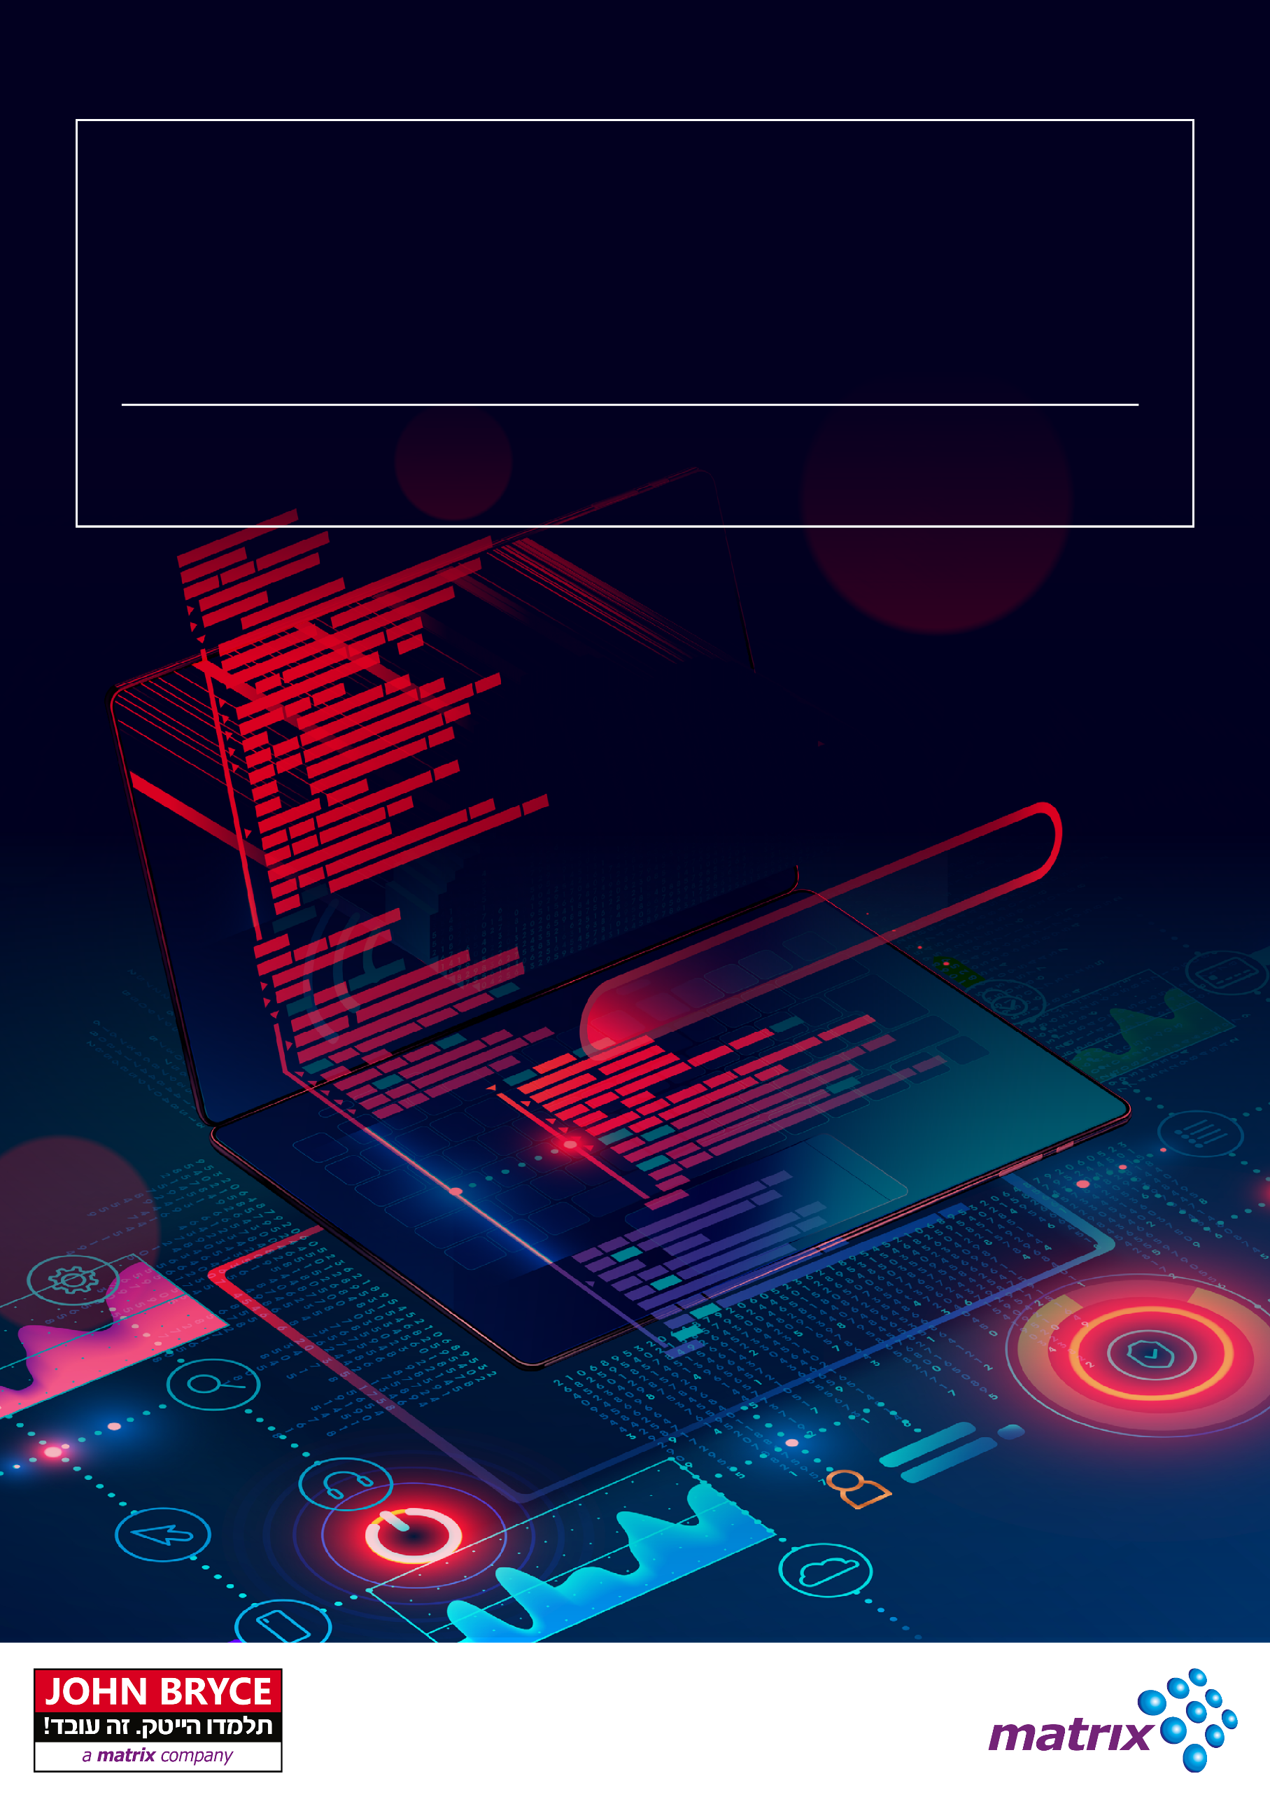

**Course 3374 | 40 Hours**

**ASP.NET 6 & Microservices**

Overview

.NET is a free and open-source managed computer software framework for Windows, Linux, and macOS operating systems. .NET Core is the Future of .NET.

Microservices are modular, small and independently deployable services that allow programmers to architecturally isolate each service, and thus create integrated applications in which pieces of code can be separately administrated, tested and enhanced.

Docker containers simplify deployment and testing by bundling a service and its dependencies into a single unit, which then runs in an isolated environment.

With .NET we can create and deploy microservices that implement all the current best practices, including Docker, containers and "Visual Studio for containers".

On Completion Delegates will be able to

* Understand the difference between a .NET framework and .NET (Core)
* Understand ASP.NET Core pipeline
* Create a Web API with validation, authentication, authorization, etc.
* Understand Docker and containers and how to use it
* Understand the needs and the challenges of micro-services world and solutions for those challenges

Who Should Attend?

This course is intended for experienced .NET developers who wish to upgrade their skills to the new Microsoft technologies & platform.

Prerequisites

Basic C# knowledge is a must.

Course Contents

**.NET (Core)**

* Introduction
* What is .NET Core
* ASP.NET Core Features
* ASP.NET Core Environment Setup
* dotnet CLI

**ASP.NET (Core)**

* Program & Startup
* Configure services & Dependency injection
* Middleware
* Common middleware
* Custom middleware
* Minimal APIs
* Logging
* Hosting & Self hosting
* **Configuration**
* WebHost default configuration
* Configuration & Dependency injection
* Appsettings Configuration
* Command arguments & environment variable configuration

**Web API**

* Creating Web APIs
* Web API Routing and Actions
* Formats and Model Binding
* Cross-origin resource sharing (CORS)

**ASP.NET Core Security**

* Authentication in ASP.NET Core
* Authorization in ASP.NET Core
* JWT
* Managing Security

**Docker**

* What is Docker?
* Docker benefits
* Docker tools
* Docker in Action
* Docker File
* Working with Images

**Microservices**

* Why & what is it?
* Creating Microservices with ASP.NET Core
* Challenges

**Microservices** **Messaging**

* Sync messages using http/https
* Use Polly & HttpClientFactory
* EventBus
* Async messages using RabbitMQ

**API** **Gateway**

* Benefits
* Routing
* Proxy



